St. Francis Institute of Technology, Mumbai-400 103

**Department Of Information Technology**

A.Y. 2024-2025

Class: TE-ITA/B, Semester: V

Subject: **DevOps Lab**

**Experiment – 5: To implement continuous integration with Jenkins**

1. **Aim:** To implement continuous integration with Jenkins
2. **Objectives:** Aim of this experiment is that, the students will be able

* To Integrate and deploy tools like Jenkins and Maven, which is used to build

applications in DevOps environment

1. **Outcomes:** After study of this experiment, the students will be able

* To understand the importance of Jenkins to Build and deploy Software

Applications on server environment.

* Learn about Jenkins (With Architecture)
* To have introduction to Maven / Gradle / Ant

1. **Prerequisite:** Knowledge of software engineering concept of integration
2. **Requirements:** Jenkins,JDK, python, ANT,Personal Computer, Windows operating system, browser, Internet Connection, Microsoft Word.
3. **Pre-Experiment Exercise:**

**Brief Theory:** Refer shared material

1. **Laboratory Exercise**
   * + 1. **Procedure:**

**a. Answer the following:**

* Explain continuous integration
* Why Jenkins is popular? Mention advantages.

**b**. **Execute following (Refer the shared material) and attach screenshots:**

* Build jobs in Jenkins

1. **Post-Experiments Exercise**
2. **Extended Theory:**

Nil

1. **Questions:**

* How is continuous integration achieved using Jenkins?
* Have you created a build job in Jenkins? Explain how to do it.
* What are the types of jobs or projects in Jenkins?

1. **Conclusion:**

* Write what was performed in the experiment.
* Write the significance of the topic studied in the experiment.

1. **References:**

<https://jenkins.io/doc/>

<https://www.cloudbees.com/jenkins/what-is-jenkins>

<https://vmokshagroup.com/blog/what-is-jenkins/>

<https://www.infoworld.com/article/3239666/what-is-jenkins-the-ci-server-explained.html>

<https://hackr.io/blog/jenkins-interview-questions>

<https://www.edureka.co/blog/interview-questions/jenkins-interview-questions/>

**7. Laboratory Exercise**

**A. Answer the following:**

1. **Explain continuous integration**

**Ans:** Continuous integration is a [DevOps](https://aws.amazon.com/devops/) software development practice where developers regularly merge their code changes into a central repository, after which automated builds and tests are run. Continuous integration most often refers to the build or integration stage of the software release process and entails both an automation component (e.g. a CI or build service) and a cultural component (e.g. learning to integrate frequently). The key goals of continuous integration are to find and address bugs quicker, improve software quality, and reduce the time it takes to validate and release new software updates.

**Key Aspects:**

1. **Frequent Integration:** Code changes are merged into a central repository multiple times a day.
2. **Automated Testing:** Automated tests are run to ensure new code doesn't break existing functionality.
3. **Immediate Feedback:** Developers receive quick feedback on the success or failure of their integration.
4. **Build Automation:** The system automatically builds and deploys the application to validate the integration.

**2. Why is Jenkins popular? Mention advantages.**

**Ans:** Jenkins is highly customizable: Its platform provides a [wide variety of plugins](https://www.hatica.io/blog/jenkins-plugins/) that allow teams or indie developers to extend its functionality, and tailor it to their specific needs. This flexibility has made Jenkins a popular choice for software development teams that require a tool that can adapt to their unique requirements.

**ADVANTAGES:**

1. Open Source: Free to use and highly customizable.
2. Extensive Plugins: Over 1,500 plugins for versatile integrations.
3. Flexibility: Suitable for various automation tasks beyond CI/CD.
4. Ease of Use: Intuitive interface and setup process.
5. Scalability: Supports distributed builds and horizontal scaling.
6. Customizable Pipelines: Allows complex and tailored workflows.
7. Active Community: Regular updates and strong community support.

**CREATING A VIEW:**

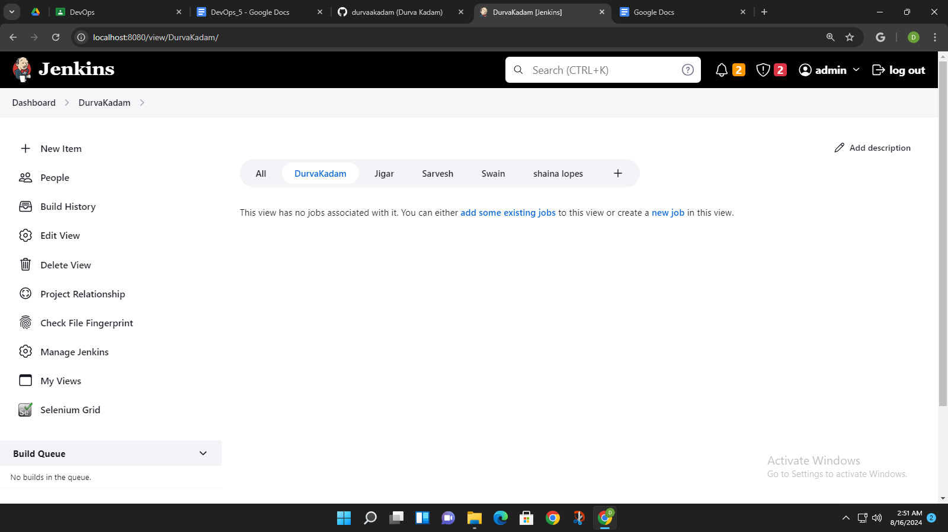

**PROJECT-1:**

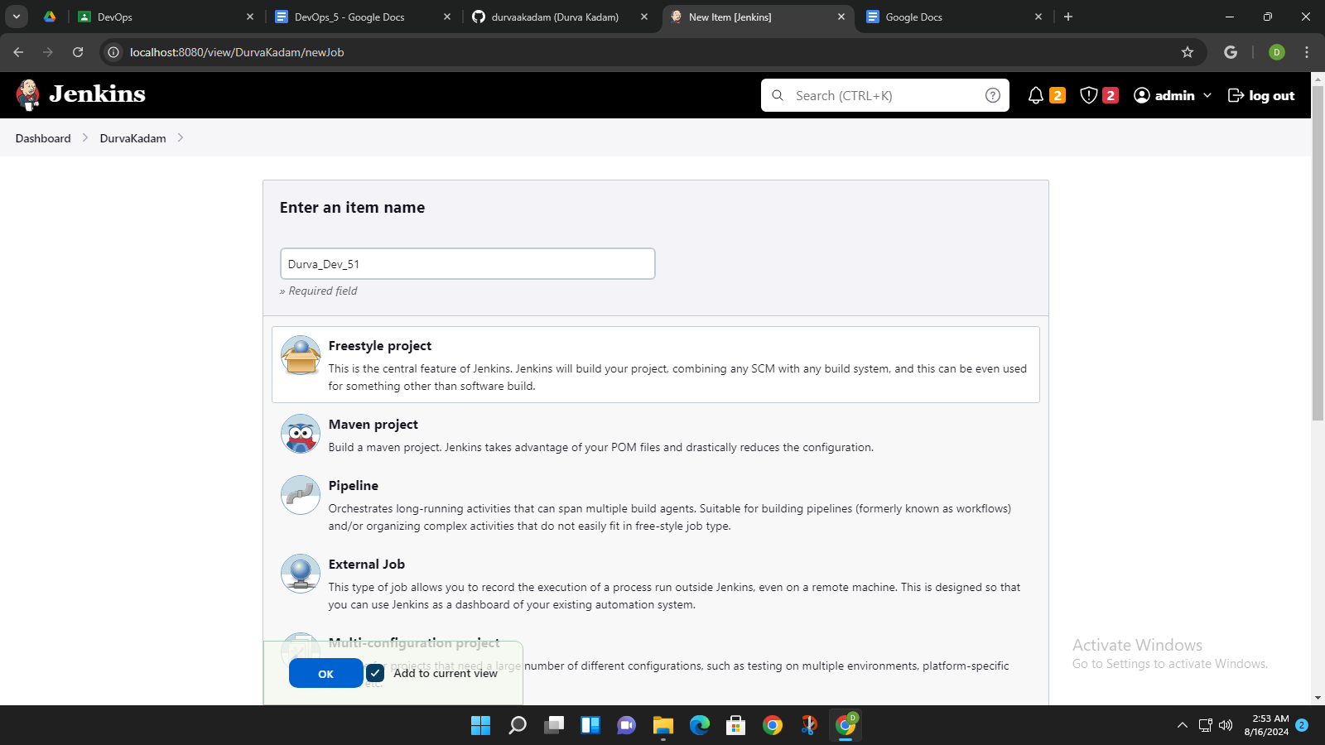

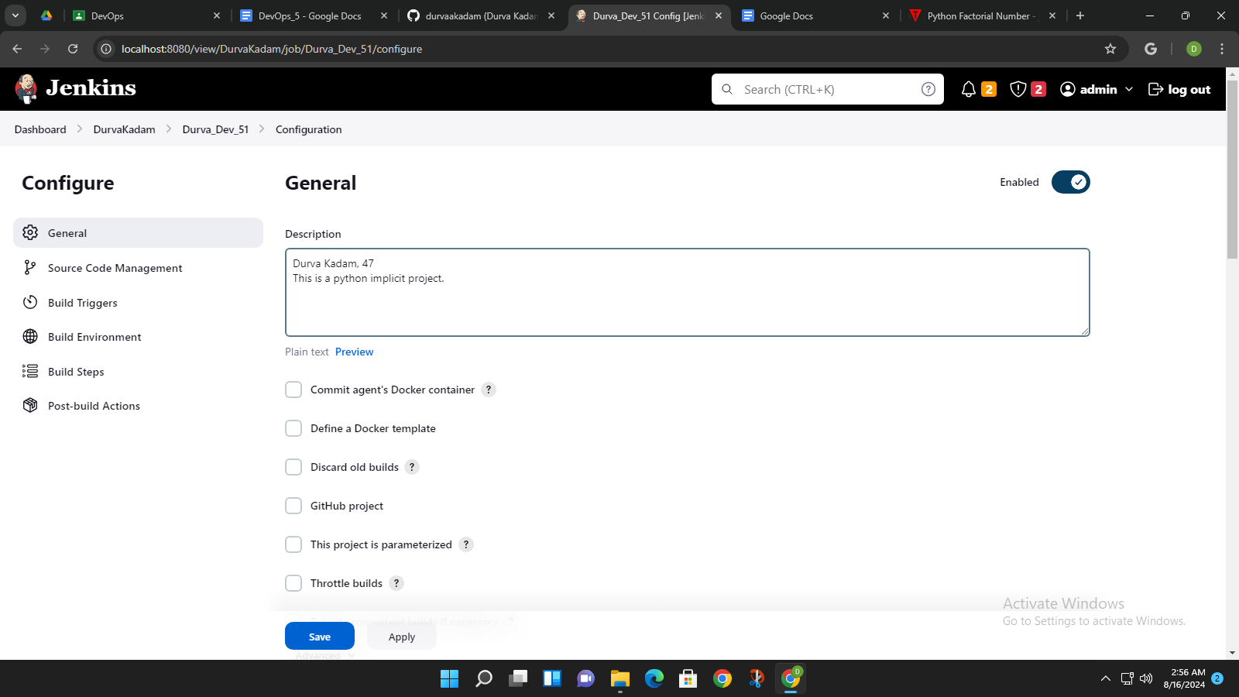

**CODE**:

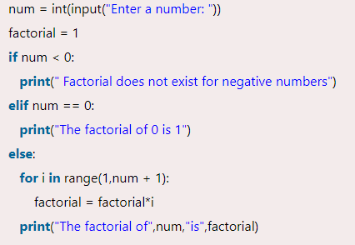

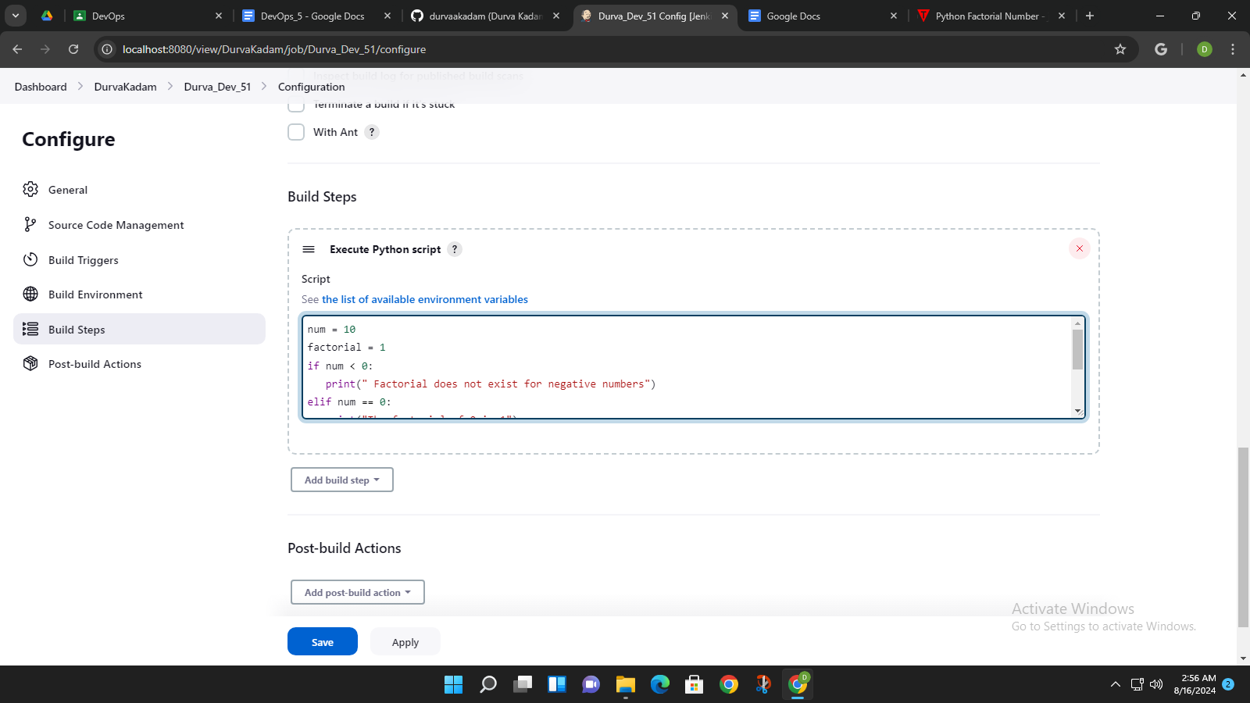

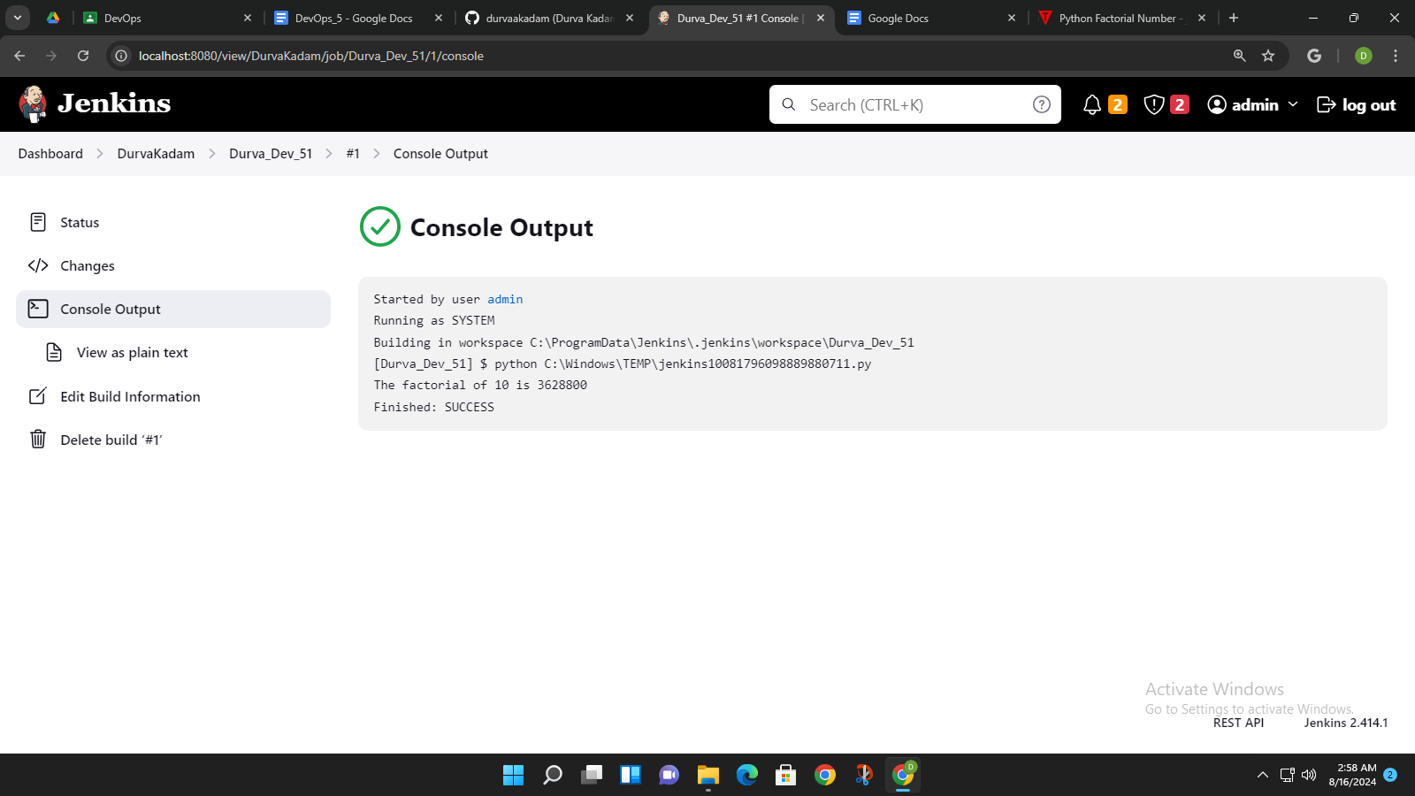

**PROJECT-2:**

CODE:

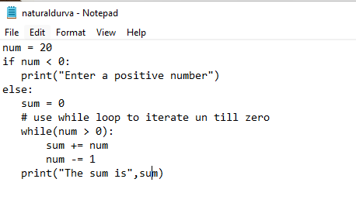

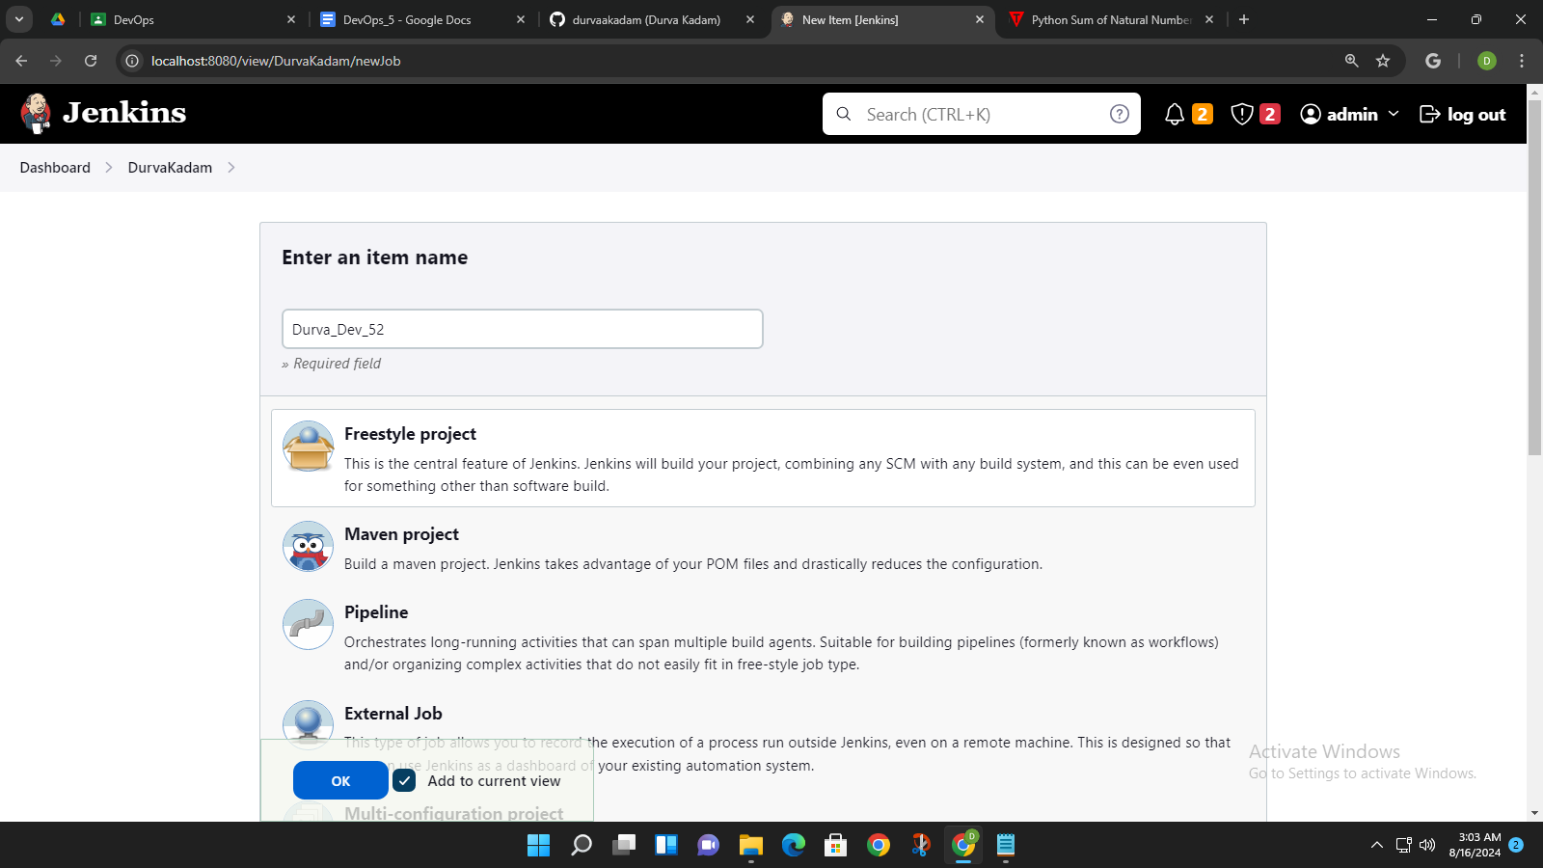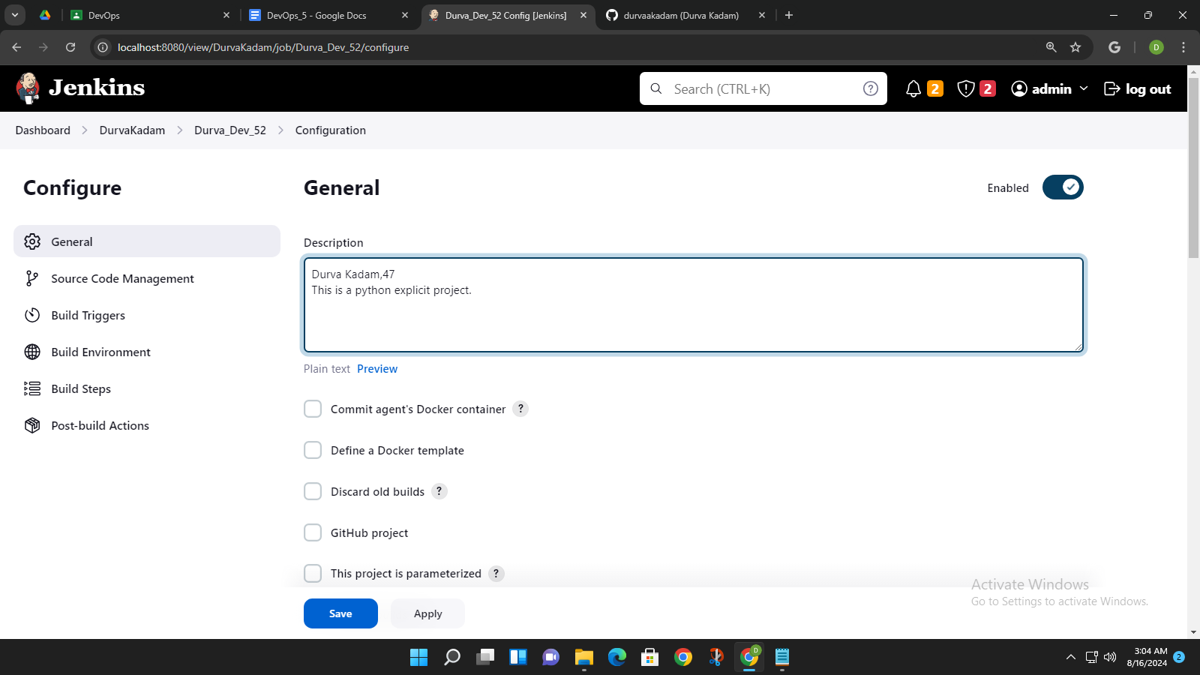

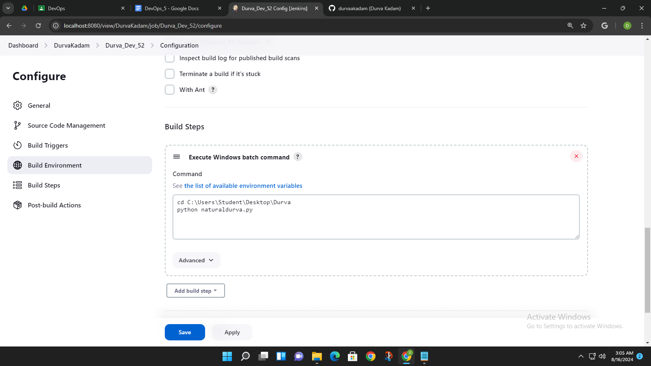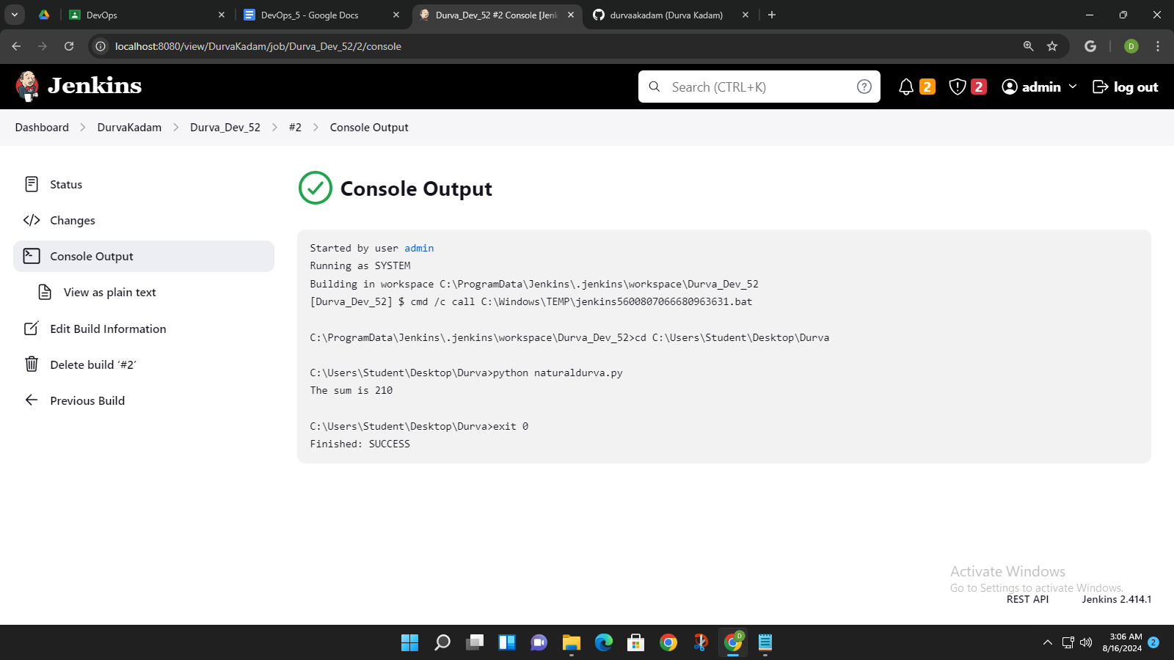

**PROJECT-3:**

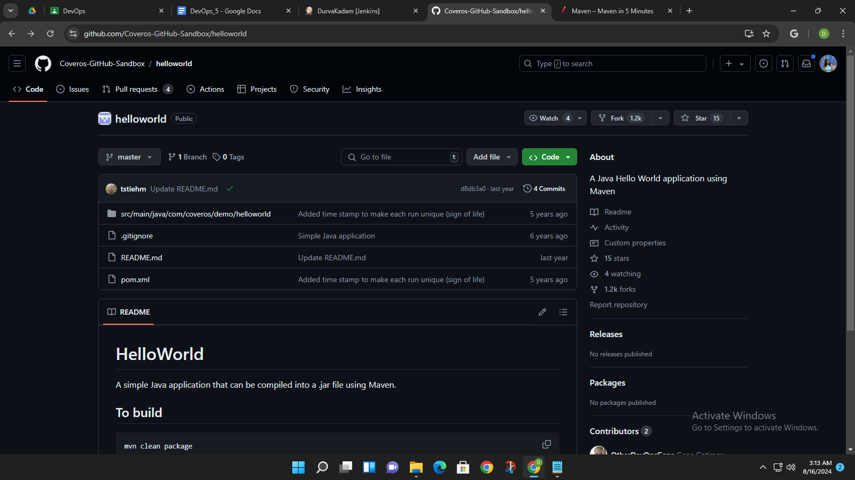

Created a fork:

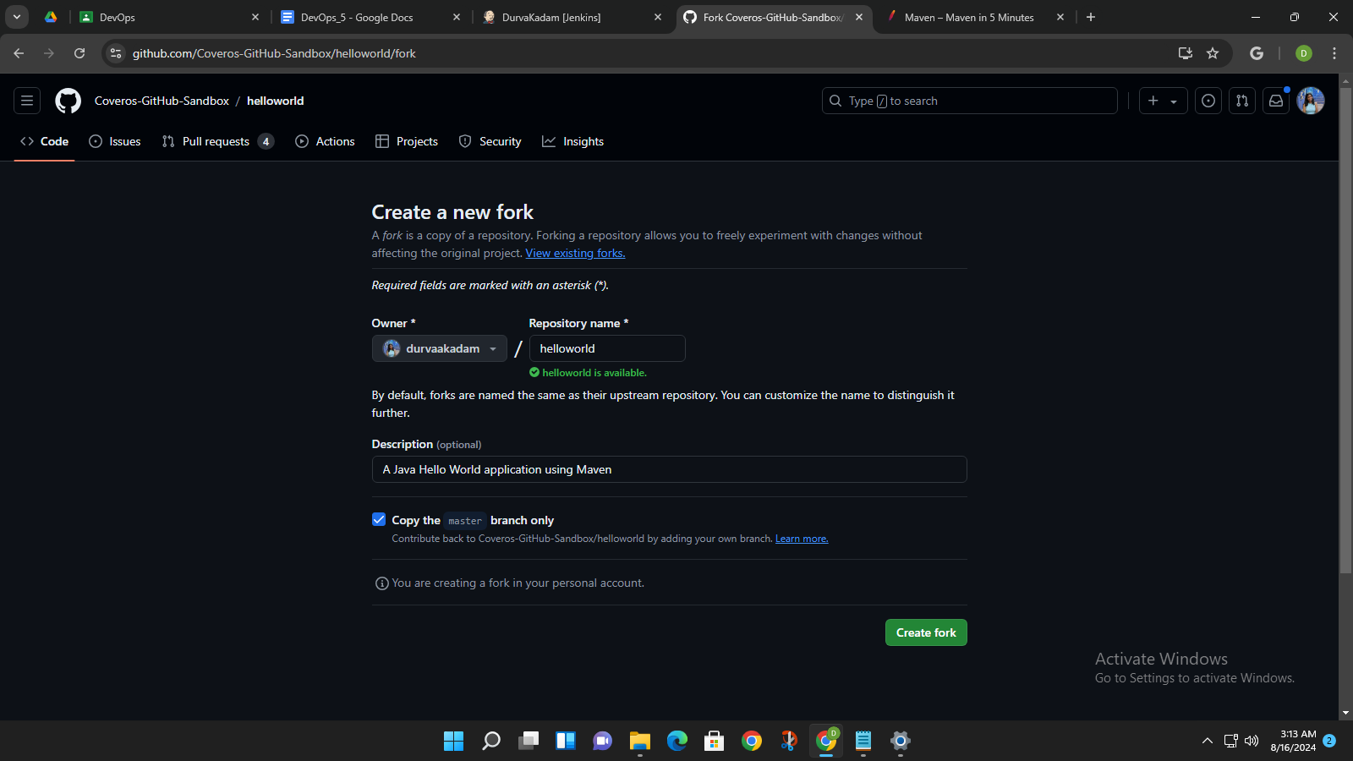

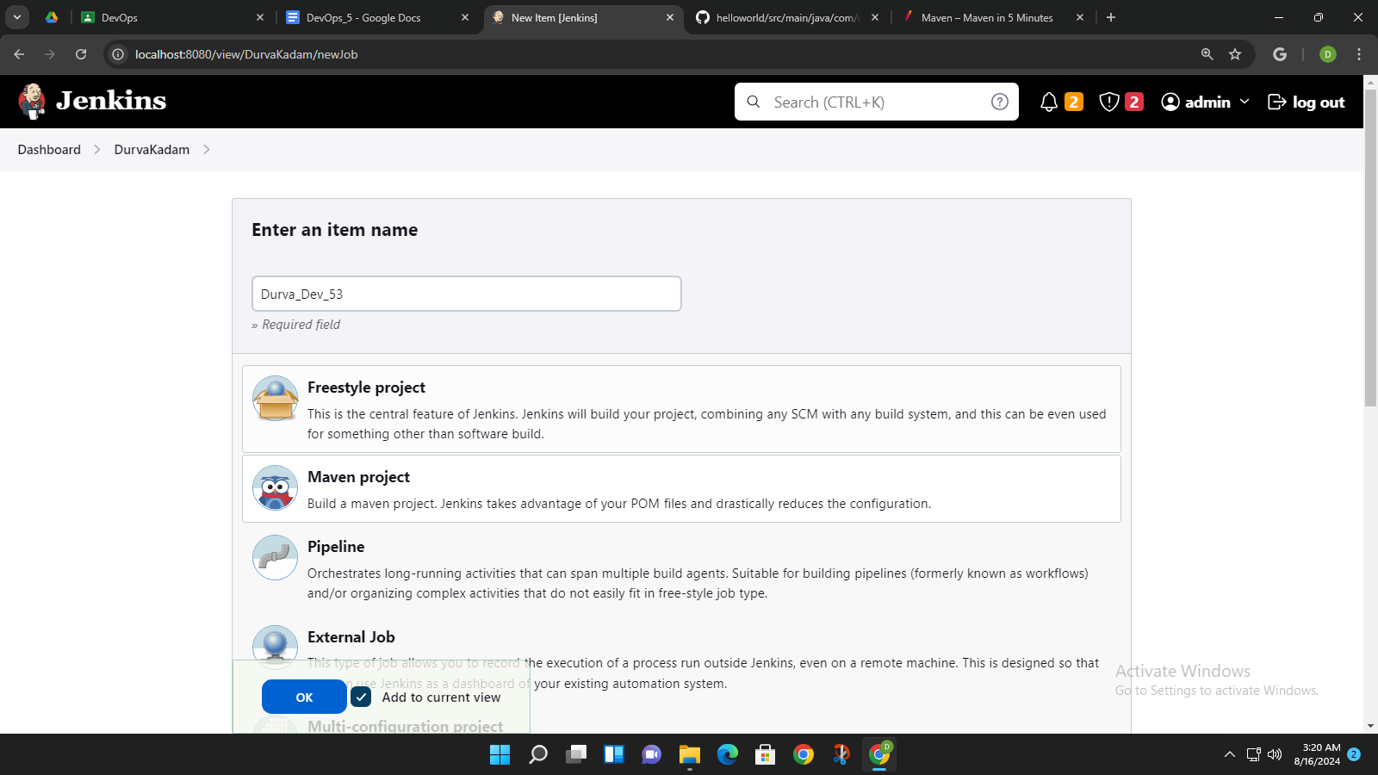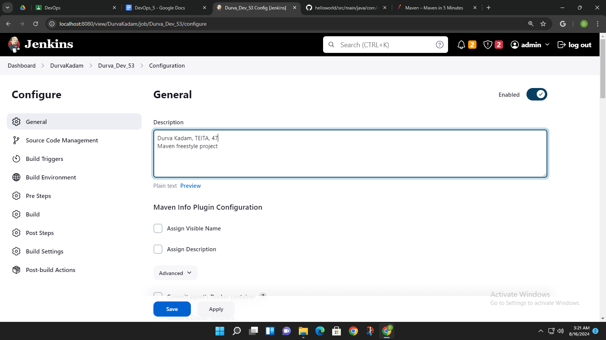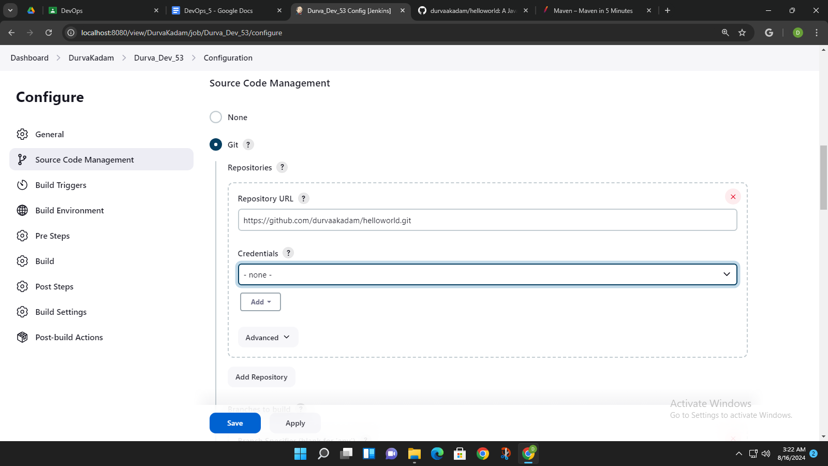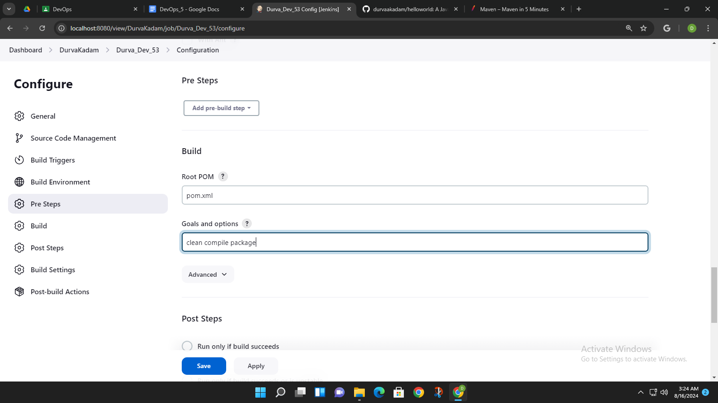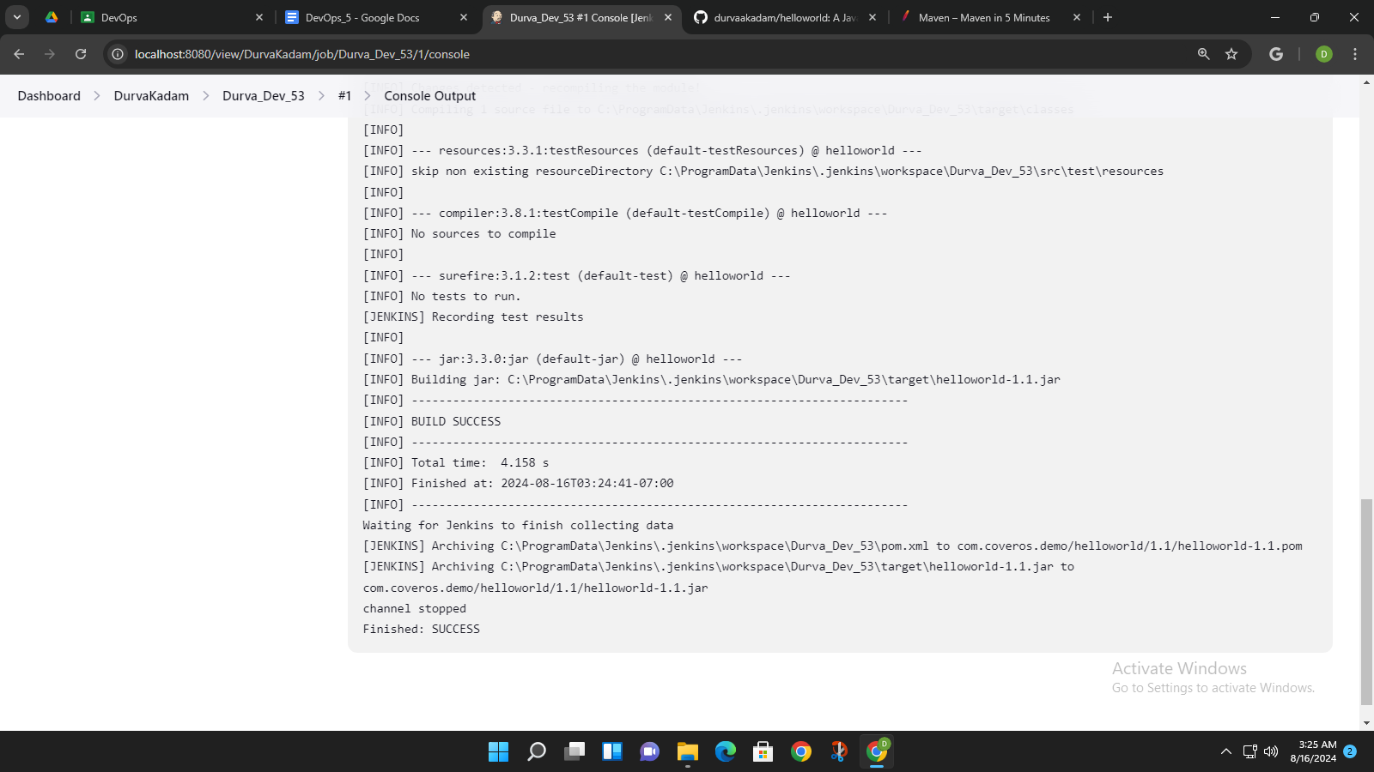

Running the jar file path from console output in the cmd(run as administrator)

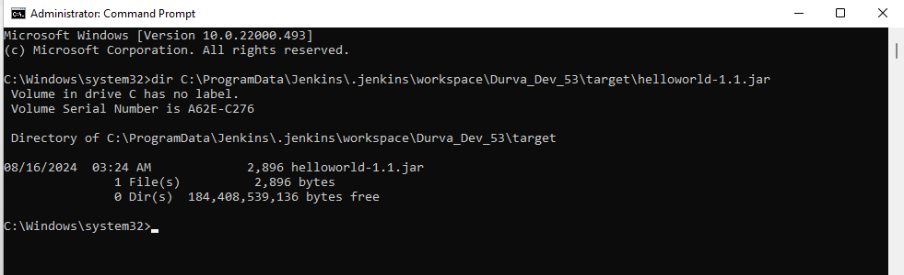

**PROJECT-4:**

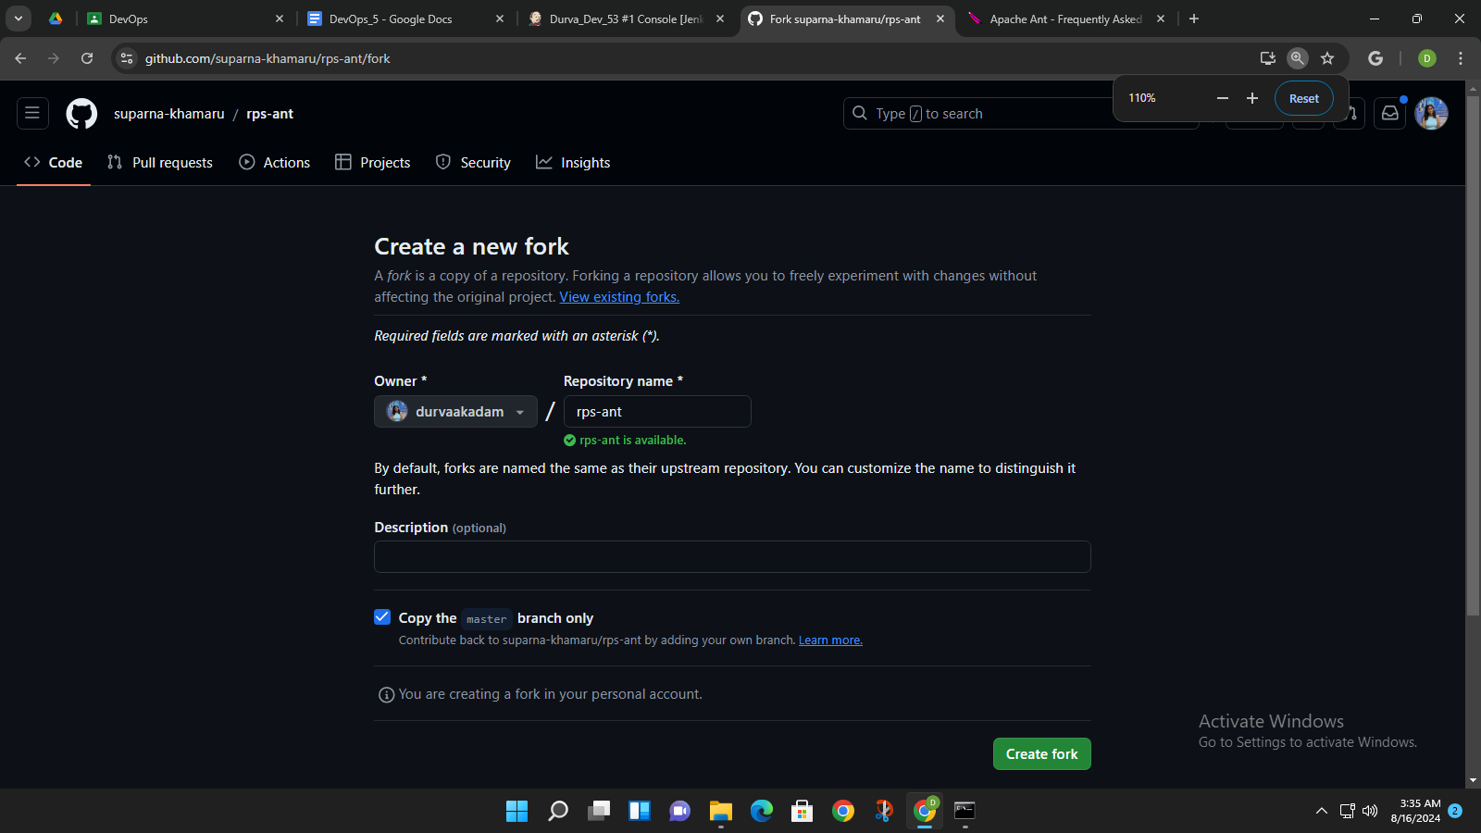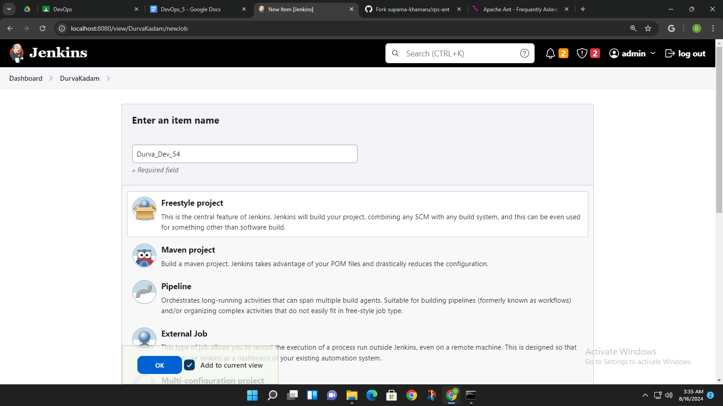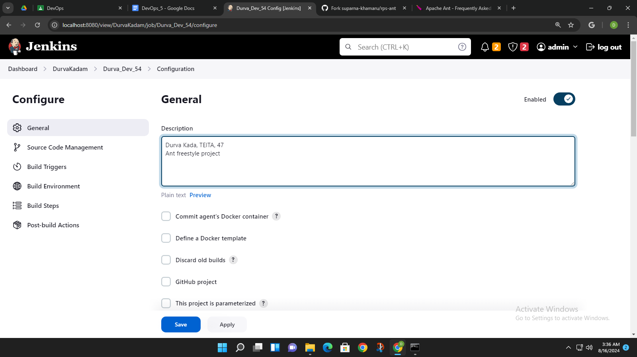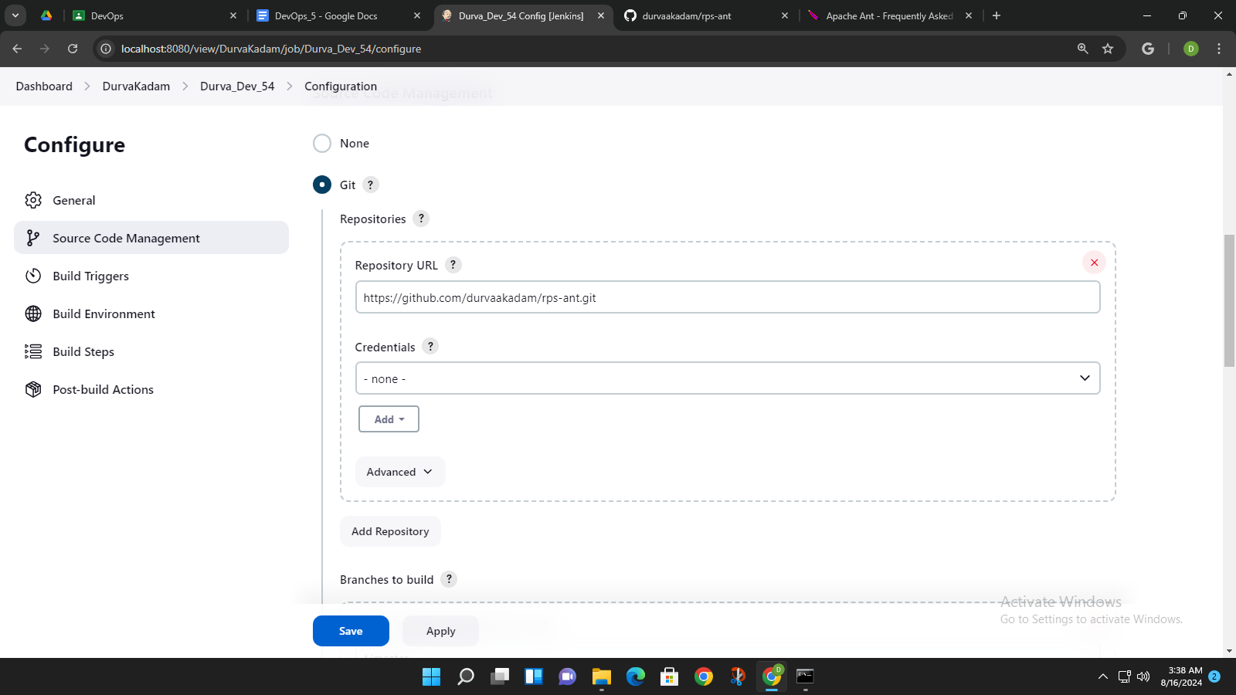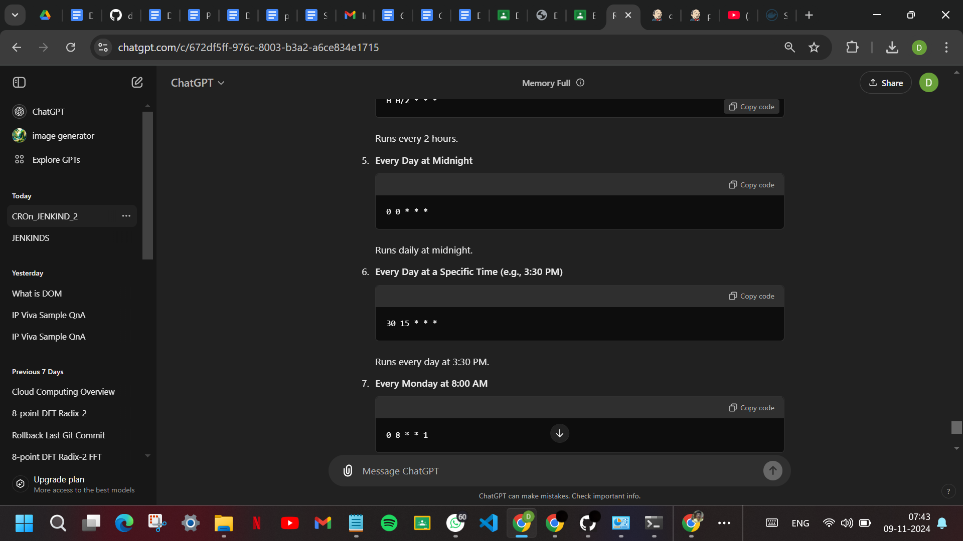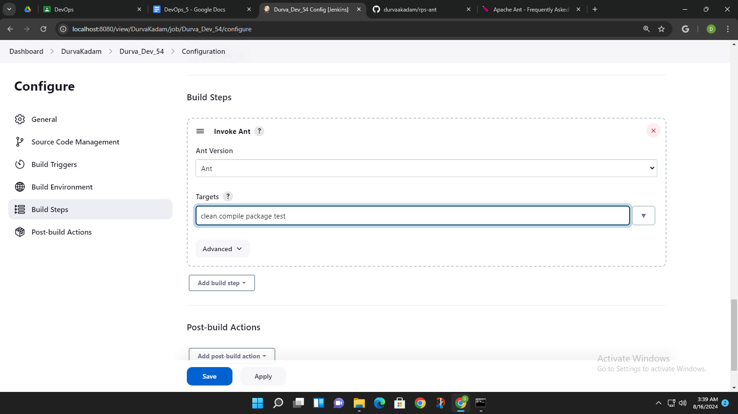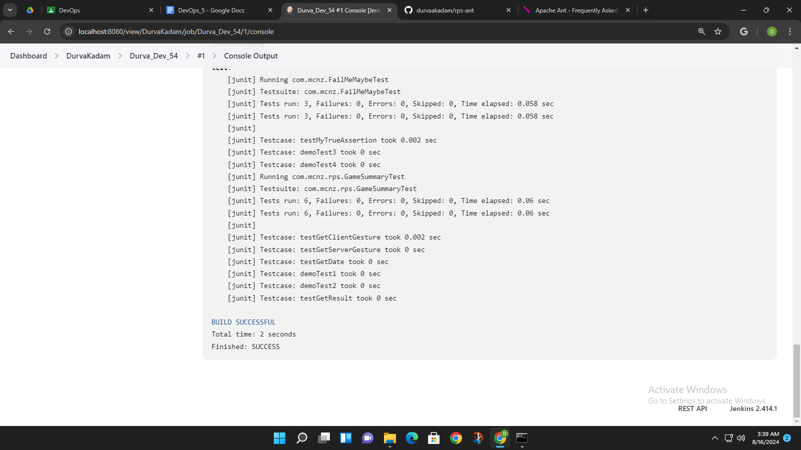

paste the war path from package section in the output in the cmd run as administartor